

ARPIE

MIDI

ARPEGGIATOR

## User Guide Firmware V6 13/9/2019

## Welcome!

Arpie is a **MIDI arpeggiator**. In its most basic application, you connect it between a MIDI controller keyboard and a MIDI controlled synthesizer and it arpeggiates chords that are held on the keyboard – meaning that it converts them into sequences of notes. There is a lot more to it than that but it’s a good basic description.

Despite its simple construction and appearance, Arpie is full featured with various chord arpeggiation, tempo synchronisation and standalone features to enable it to be used creatively with or without an attached keyboard.

Arpie is based around open-source software and hardware. The Arduino-based firmware allows maximum hackability and the hardware is designed for easy DIY assembly and customisation.

## Know Your Arpie

The Arpie front panel looks like this

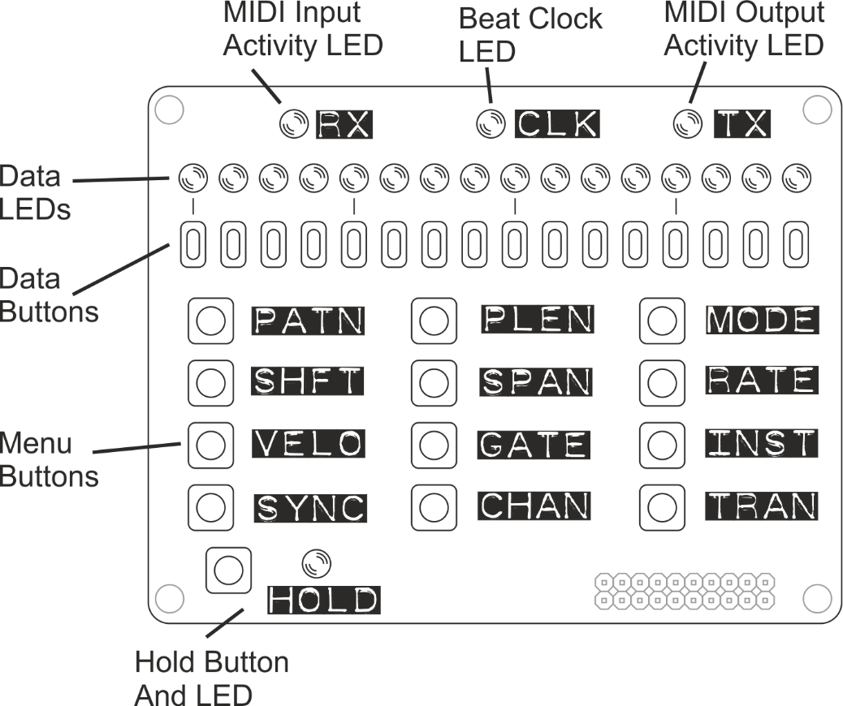

With some exceptions, most functions of the Arpie are accessed by selecting a menu option by pressing one of the 12 **menu buttons**, then changing the data associated with the menu option by pressing **data buttons**. The **data LEDs** provide visual feedback on the data associated with the menu option.

Most of the menu buttons have two functions; the first function is selected by clicking (pressing and releasing) the menu button and the second function is selected by holding it down for a longer period of time. The data LEDs change to represent the second (“long press”) function when this time has elapsed.

After a function is selected, Arpie will revert back to the “normal” display (PATN) after a few seconds if no data button is pressed. This auto revert can be switched off if preferred (long press PLEN menu)

In this document, long-press (second) functions are indicated with an asterisk(*) at the start of the key name. For example, *MODE is the long press function of the MODE button.

Arpie has connectors and additional switches around the sides. The location of these when viewed from the top is indicated below

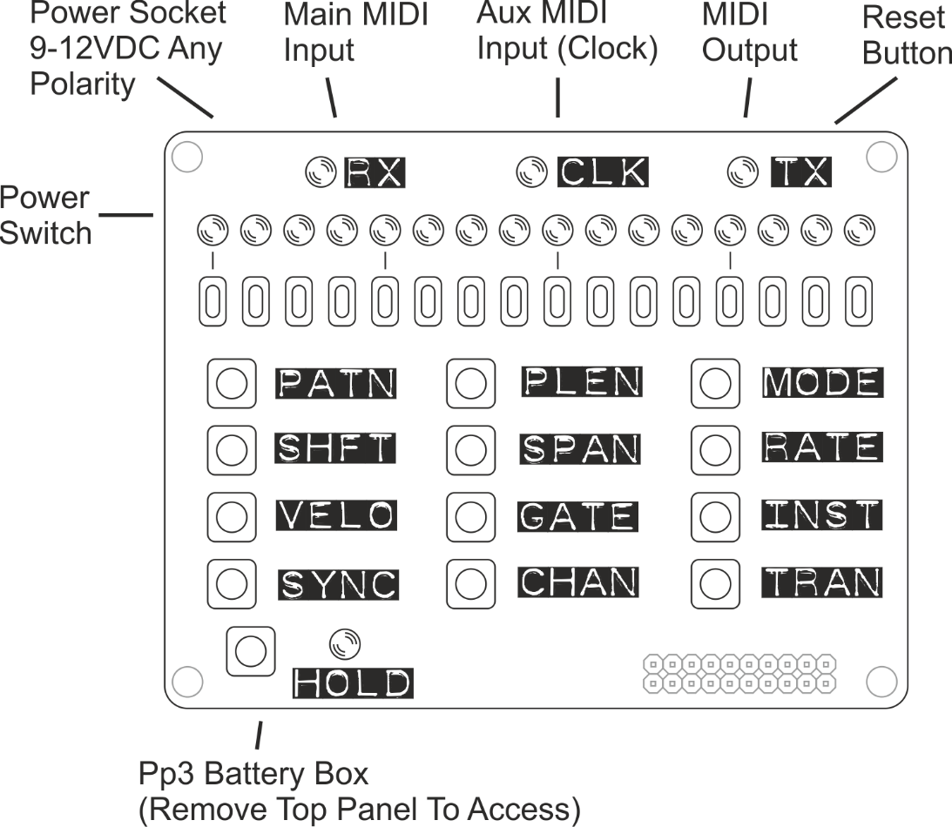

* Arpie can take **power** from any DC supply with 100mA or more current capacity and a voltage of 9-12V. The connector is a barrel type with a 2.1mm pin. Arpie can accept power with either positive or negative tip polarity. Then a plug is inserted, the internal battery is disconnected.
* The **main** **midi input** connector accepts MIDI input from a standard 5-pin DIN connector, generally from a controller keyboard.
* The **aux midi input** accepts MIDI clock messages only via a standard 5-pin DIN connector. This input can be used to accept a MIDI clock from a different device to that providing the chords.
* The **midi output** connector accepts a standard 5-pin DIN connector and is generally connected to a synth or sound module.
* The **reset button** performs a hard reset of ARPIE, equivalent to a power off/on cycle. This is typically most useful when loading new firmware.
* The **battery box** accepts a 9V PP3 battery (Alkaline batteries recommended). To replace the battery, remove the four screws that secure the control surface and pull the panel and connector pins from their socket.

There are several other connectors and indicators on the lower board which are used less often and sometimes only for diagnostic purposes. These are as shown below

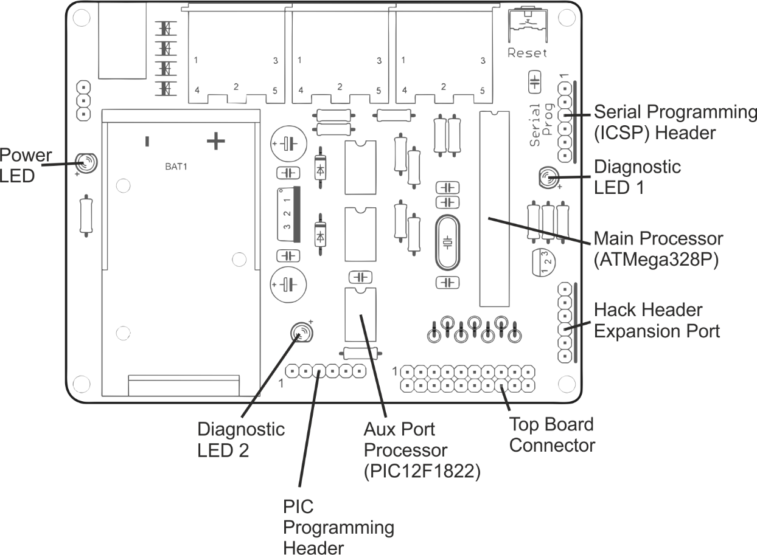

* The **Power LED** should be on the whole time Arpie is being powered
* The **hack header** breaks out 5V power and four spare I/O lines from ARPIE’s microcontroller. It allows DIY add-ons or connection of “tab” expansion boards as described later.
* The **programming header** is used to load new firmware on to the Arpie processor, using a suitable USB programmer.
* **Diagnostic LED 1** is connected to the main **ATMega328P** microcontroller - ARPIE's "brain". When the brain is alive, this LED should blink about once per second.
* **Diagnostic LED 2** is connected to the **PIC12F1822** microcontroller that manages the aux midi port. This LED should blink every second or two.
* **PIC Programming Header** can be used to update firmware on the PIC chip, using a PICKit2 type programmer. Usually it would be rare to need to do this, and typically there is no need to solder a header here

## Chord Building

ARPIE builds melody and basslines by ‘arpeggiating’ chords that you play (playing all their notes in sequence). This process has the following steps

First a **chord is built** – this is usually done by playing a chord on an attached MIDI keyboard, however you can also enter a chord manuallyor select a fixed or random chord.

If you are controlling Arpie using a MIDI keyboard, make sure that the MIDI OUT of the keyboard is connected to the MIDI IN of Arpie and that the MIDI output channel of the keyboard matching the input channel of Arpie (Long press CHAN button)

Use the HOLD button to keep a chord playing after you release the keys.

## Arpeggiation

The chord is then built into an arpeggiated sequence (**arpeggio**). A chord typically only has a few notes (e.g. 3 or 4), so in order to make arpeggios more interesting, we can extend them in various ways:

* Firstly we can **extend** the chord into multiple octaves – we can add up to 3 more octaves on top of the played chord (SPAN function) and we can also transpose the chord itself up or down by three whole octaves (SHFT function)
* Next, the resulting set of notes are **sorted into order**, such as ascending pitch, descending pitch, ascending then descending pitch, randomised order etc (MODE function)
* The final step in building the sequence is an option to **extend the sequence** further by repeating certain notes (INST function). This allows us to alternate every note with the highest or lowest note in the sequence or to “fold” the sequence (e.g. 3 steps forward, 1 step back).

After the above steps, a simple chord of a couple of notes can be extended into an arpeggiated sequence containing tens of notes.

## The Trig Pattern

The arpeggiated sequence can then be played into your synth. You will need to ensure that the MIDI OUT of Arpie is connected to the MIDI IN of your synth and that the output channel of Arpie (CHAN button) matches the selected input channel of the synth.

The rate of playback of the notes is determined by the BPM (SYNC function) and the musical measure of each step (RATE function).

Each note is played with a duration that is a proportion of full step time or until the start of the next note (GATE function) and with a MIDI velocity that is controlled by the VELO function and on a MIDI channel controlled by the CHAN function.

ARPIE allows extra variation of a sequence to be added at this point via the **trig pattern** (PATN function); this is a sequence of “triggers” (up to 16 of them, as defined by PLEN function) which control how each step in the arpeggiated sequence plays. The trig sequence can add apply variations such as muting a step, adding velocity accents, transposing a step, extending the gate duration of a step or tying a step to the next.

The trig pattern plays back at the same rate as the arpeggiated sequence, however it does not need to be the same length. This means that different notes may aligning with each trig each time the patterns loop around, creating interesting variations. You can explore these by experimenting with the pattern length (PLEN) and the arpeggiation options.

## Transposition and Forcing to Scale

As well as transposing by full octaves (SHFT function), ARPIE allows **chromatic transposition** (TRAN function) so you can transpose the arpeggio up or down by just a few semitones. The two transpose features work together, so you can transpose (for example) down by 2 octaves then up by 3 semitones.

Chromatic transposing may change the musical key of the arpeggio and sound wrong (or it could be an effect you are going for!). However, if you want to transpose the arpeggio but remain in a fixed musical key, ARPIE has a **force to scale** mode (Long-press SHFT and Long-press SPAN). Using the force to scale options makes transposition sound more musical.

The TRAN function allows you to transpose playback up or down with a single keypress. You can also perform transposition by playing notes on an attached MIDI keyboard (see HOLD long press function)

Via the TRAN function it is possible to **sequence transposition** so that it happens automatically, with a pre-defined sequence of transpositions advancing each time the trig pattern loops. When used with the force-to-scale options, this allows chord progressions and even song structures to be created on the fly.

## Menu Functions

The following sections describe the functions of each menu button in turn.

The second function of a menu button (i.e. long press function) is indicated with an asterisk before the button name (e.g. *MODE)

|  |  |
| --- | --- |
| PATN | Trig Pattern |

During normal use of the ARPIE, the data LEDs show the “current layer” of the trig pattern - this is usually the play/mute layer.

To change to another layer, hold down the PATN key and press the button below the LED for the required later as shown below

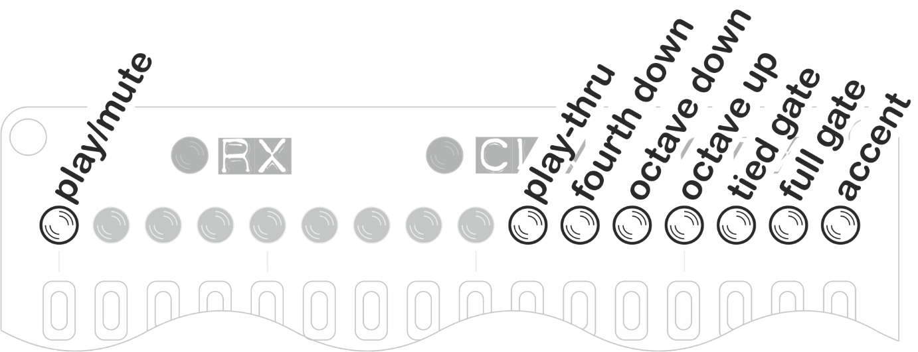

**Play-mute** is the default layer, showing which of the trig pattern steps are active (i.e. where the corresponding note from the arpeggiated sequence will be played). Usually the note in the arpeggiated sequence is skipped over and not played when the trig is inactive, however the separate note skip option (Long press MODE) allows the sequence to advance only on active steps, so no notes are skipped.

Starting from the right, the other options are:

The **accent** layer causes the note to play with accented MIDI velocity (Long press VELO). If the CV TAB is connected you can also optionally send an accent trigger at these steps.

The **full gate** option causes the note duration (via MIDI and CV TAB gate output) to be equal to one full sequencer step for the specific note. This overrides the duration set via the GATE function. The full gate option sounds best when combined with short GATE settings to create rhythmic variation.

The **tied gate** option causes the note to be played ‘legato’, meaning that the MIDI note is stopped only when the next note has started playing. Depending on your synth, this can produce a glide between the notes. If you have the CV TAB, a voltage glide is triggered. The voltage sweeps from the current level (i.e. left from the last note) up to the level of the new note, over a full step time and the gate remains open for 1 step.

The **octave up**, **octave down** and **fourth down** options transpose the note at the current step by the stated amount

The **play-thru** option allows consecutive notes from the arpeggio to play over MIDI as a chord. Consecutive steps that have play-thru set are skipped through together

|  |  |
| --- | --- |
| PLEN | Trig Pattern Length |

Pressing the PLEN button selects the active length of the trig pattern between 1 and 16 steps. Press the button below the required step position to change the length of the trig pattern.

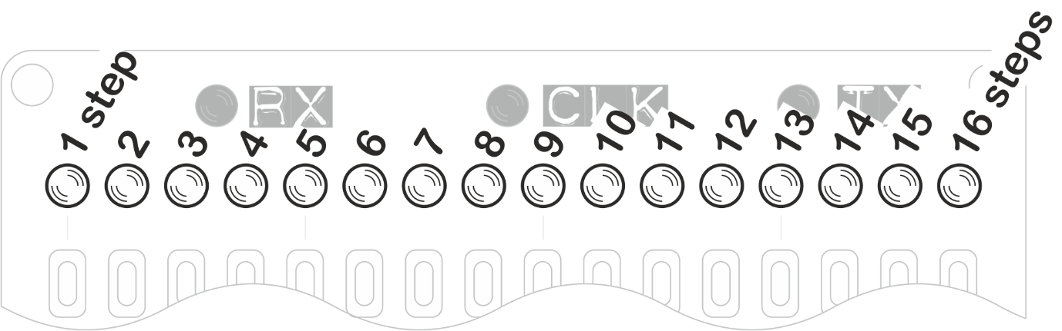

During playback the trig pattern loops from step 1 up to the step you select. The trig pattern is applied to the arpeggio sequence, which generally has a different length. By selecting a trig pattern length which does not divide simply into the length of the arpeggio sequence, you can get patterns that play for several bars without repetition.

|  |  |
| --- | --- |
| *PLEN | Config Preferences |

Press and hold PLEN to access the configuration preferences:

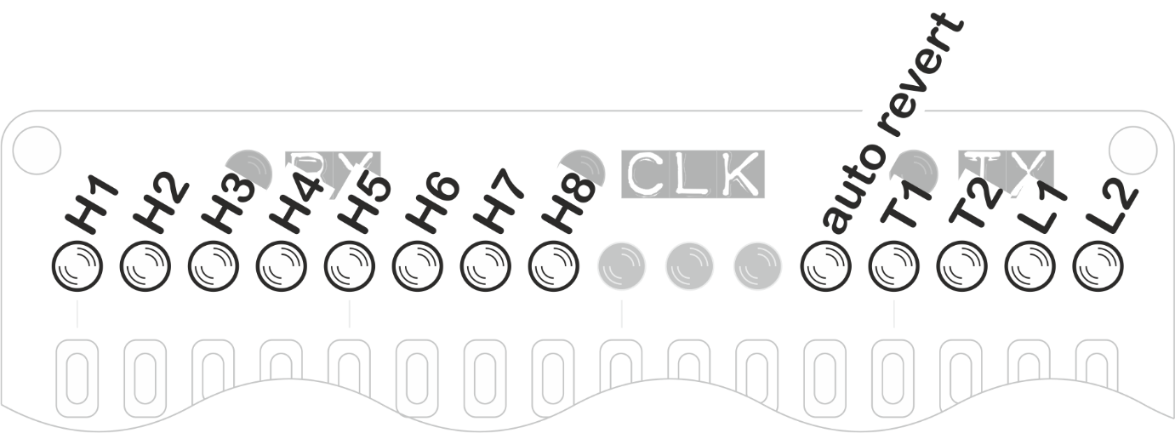

H1 through H8 control built-in functionality for the hack header (the small expansion header on the ARPIE base board) mode. The function of each LED depends on the selected hack header mode, which is described later.

Auto Revert controls whether ARPIE will time out to the PATN menu when no buttons are pressed for about 10 seconds. Turn this off if you prefer - you can always press the PATN button to get back!

T1 and T2 (Long Press time) control how long you need to hold down one of ARPIE menu buttons to access it’s second function.

|  |  |  |
| --- | --- | --- |
| **T1** | **T2** | **Long Press Time** |
| OFF | OFF | 0.25 seconds |
| OFF | ON | 0.5 seconds |
| ON | OFF | 1 second |
| ON | ON | 1.5 seconds |

L1 and L2 (LED Profile) set the how the 16 data LEDs are controlled. Different types of LEDs have different characteristics; some are much brighter than others and need to be driven at shorter ‘duty cycles’ to get a decent contrast between the 3 different LED brightness (bright, medium, dim). The LED profile shown below are recommendations but you may prefer to use a different one (don’t worry, it won’t damage the LEDs to use the ‘wrong’ profile!)

|  |  |  |
| --- | --- | --- |
| **L1** | **L2** | **Recommended For** |
| OFF | OFF | Super bright white LEDs |
| OFF | ON | Super bright blue/green LEDs |
| ON | OFF | Bright red LEDs |
| ON | ON | Standard brightness LEDs |

All preference settings are saved in EEPROM. This means they are remembered when ARPIE is switched off.

|  |  |
| --- | --- |
| MODE | Arp Mode / Set All Trigs |

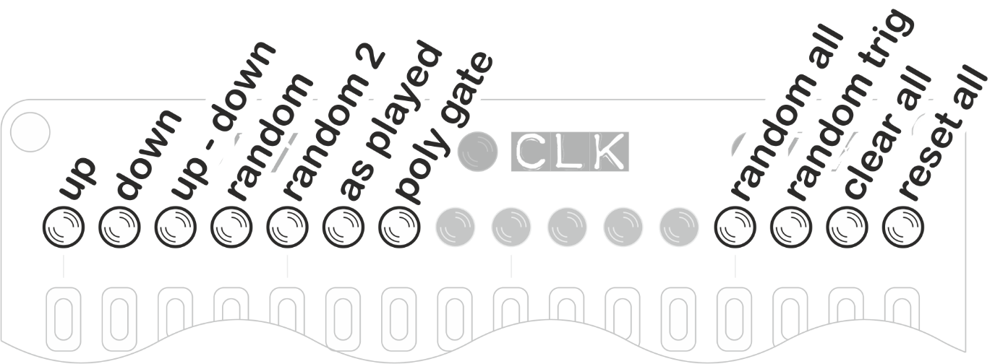

This option allows you to select between ARPIE arpeggiation modes:

* **up** mode plays notes of the chord in ascending order
* **down** mode plays notes of the chord in descending order
* **up-down** plays notes of the chord in ascending then descending order. If the sequence spans multiple octaves, all octaves are spanned on the way up before returning down.
* **random** plays the notes of a chord in a random order. This randomised order is determined when the arpeggio is set and is repeated until the arpeggio is reset (e.g. press the Random Mode button again)
* **random2** plays the notes of a chord in a random order which is re-shuffled each time the arpeggiate sequence completes, so the sequence continually changes
* **as played** plays the notes of the chord in the order they are received on the MIDI input.
* **poly gate** plays all the notes of the chord at the same time. Thicken up with SPAN and add some groove with PATN to get some classic chord stabs!

The right side data entry buttons can be used to reset the PATN and PLEN information.

* **random all** applies random accent, tie, gate length, octave shift to all steps that are active in the rhythmic pattern
* **random trig** randomises the rhythmic pattern, making random steps active
* **clear all** sets all steps to mute (LED off) and sets PLEN to 16 steps
* **reset all** sets all steps to play (LED on) and sets PLEN to 16 steps

|  |  |
| --- | --- |
| *MODE | Performance Options |

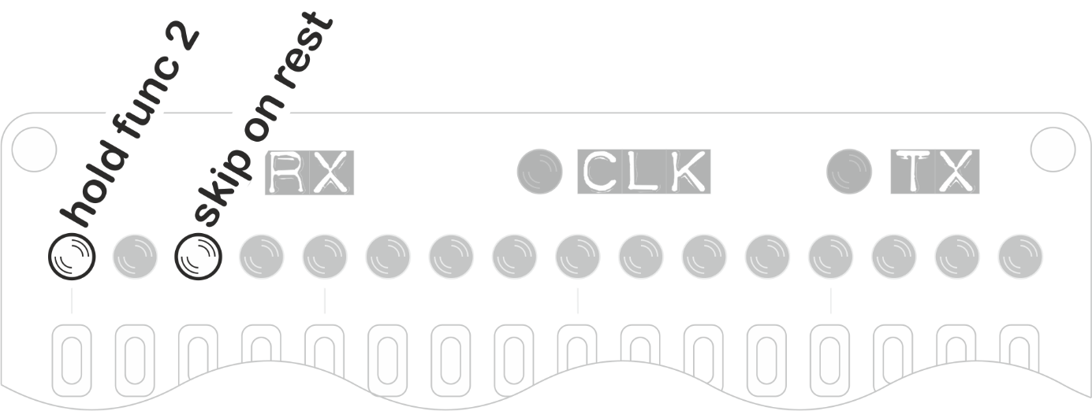

Press and hold MODE to access the Performance Options. This menu contains settings that control other ARPIE functions, changing the musical performance.

* **hold func 2** controls the long-press function of the HOLD button. When this option in ON, the second function of HOLD is MIDI lock. When the option is OFF the second function is transpose by MIDI input.
* **skip on rest** controls what happens when there is a rest (LED off) at the current position in the PATN sequence. If the option is OFF, the note at that position is skipped over and does not play. If the option is ON, the arpeggiator inserts a rest and plays the note at the next step.

|  |  |
| --- | --- |
| SHFT | Octave Shift |

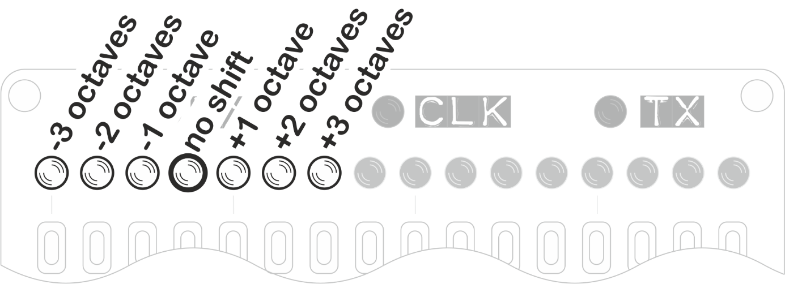

This function transposes the arpeggiated sequence up or down by 3 whole octaves.

|  |  |
| --- | --- |
| *SHFT | Scale Root Note |

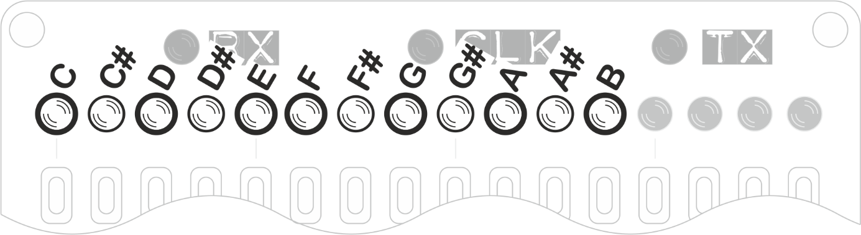

This option works with Force To Scale Mode (long press SPAN) to set the root note of the musical scale into which notes are forced. For example, if force to scale root note is set to D# and force to scale mode is Locrian, notes will be forced into a D# Locrian mode.

|  |  |
| --- | --- |
| SPAN | Octave Span |

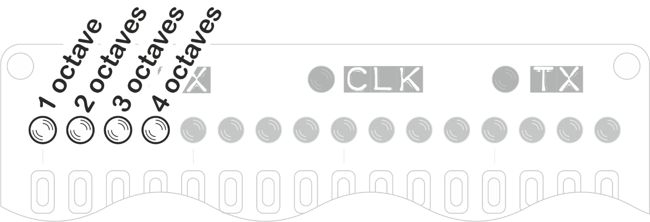

This option determines the range of octaves the arpeggiated sequence will extend over. This also works in polyphonic gate mode to layer additional octaves worth of notes on the chord.

|  |  |
| --- | --- |
| *SPAN | Force to Scale |

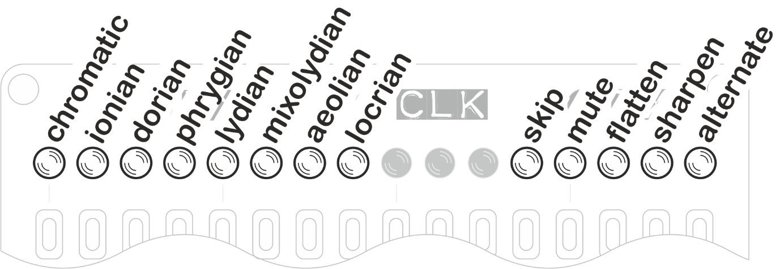

Arpie’s Force To Scale feature makes sure that all notes from the ARPIE fit within a specific musical scale (or key). This can sound especially good when transposing held arpeggios, as the note intervals within the chord change to keep it in key.

A musical key is made up of a root note (for example ‘C’) and a set of note intervals, which together give us a scale (e.g. ‘C minor’).

These sets of note intervals have weird names derived from ancient Greek tribes! Don’t let that put you off though - they are just the sequences of note intervals you get when you play along the white notes of a piano starting at different points.

For example, if you play white notes C through C you play a Major scale, which happens to be the same as the ‘Ionian’ mode. If you play white notes A through A you are playing a Minor scale, or ‘Aeolian’ mode. The other modes are just the sets of intervals you get by playing sequences of white notes with different start points… simple! Each mode has a different feel, so have fun experimenting with them!

* The chromatic scale includes all notes. Selecting this option effectively turns off force-to-scale. This is the default setting.
* The Ionian mode is equivalent to the intervals between all the white notes on a piano keyboard from C to C. It is the same as the normal major scale.
* The Aeolian mode is equivalent to the intervals between all the white notes on a piano keyboard from A to A. It is the same as the natural minor scale.
* The other modes follow the same pattern of white notes from D to D (Dorian), E (Phrygian), F (Lydian), G (Mixolydian) and B (Locrian). Each is a different way of dividing up the 12 semitones of an octave into 8 notes and has a different feel.
* As well as changing musical mode, force-to-scale lets us select the root note (we need both a musical mode and a starting note to define a scale) and control how out of scale notes are corrected.

To the right of the musical modes are a set of options that control what happens to those notes that do not fit within the selected scale. If you want to make an omelette you need to break a few eggs - and if you want to force a sequence of notes into a musical scale some of them just might not fit! Each option has a different musical feel, so play around – you may find something amazing.

* **skip** means out-of-scale notes are ignored and the next valid note is played. There is no rest introduced.
* **mute** means out-of-scale notes are not played, but a rest of a single step is added instead.
* **flatten** means out-of-scale notes are played, flattened by 1 semitone to bring them back into key.
* **sharpen** means out-of-scale notes are played, sharpened by 1 semitone to bring them back into key.
* **alternate** means that out-of-scale notes are alternately sharpened and flattened. Each time the sequence is rebuilt, the action taken with the first corrected note toggles. You can hear the effect of this by pressing the Alternate button again when you have a sequence which is forced to scale.

|  |  |
| --- | --- |
| RATE | Step Time Division |

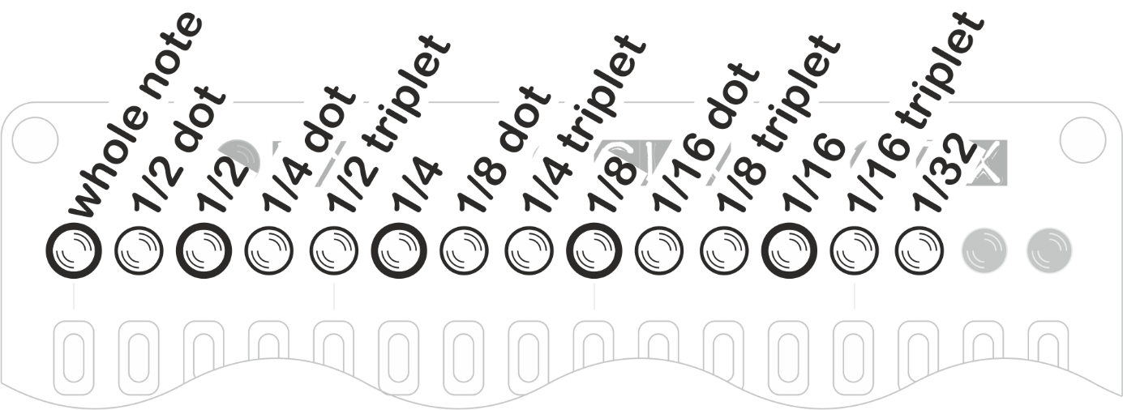

This option sets the length of notes in the arpeggiated sequence, as a fraction of a beat. While the BPM stays the same, the arpeggio will play faster or slower as the beats are divided up differently.

The default ‘normal’ note time (at least in 4/4 time) is one sixteenth of a beat, so for example selecting 1/8 will play notes half the speed for a given BPM.

* **dot** means represent dotted time (one and a half times normal note duration)
* **triplet** represents triplet time (two thirds normal note duration)

|  |  |
| --- | --- |
| VELO | MIDI Note Velocity |

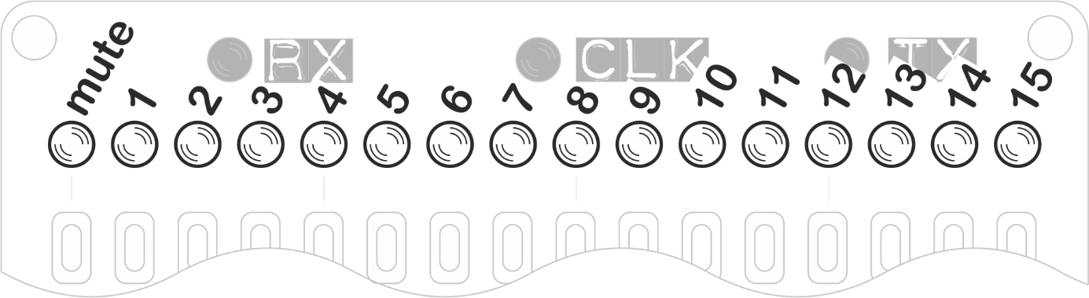

This menu controls the MIDI velocity of the notes output by the ARPIE. There are two velocity modes, described as follows:

* **Manual Velocity mode** allows you to override the velocity of all arpeggiated notes to mute them completely, or select one of 15 levels up to full MIDI velocity In this mode, the original velocity information from the controller keyboard is ignored.
* To switch to **original velocity mode**, press the first data button (mute) twice. Original velocity mode plays each arpeggiated note using the velocity as it was played on the controller keyboard. This mode can be identified by the left and right-most LEDs being on and all the others off. To switch back to selected velocity mode, press any velocity button, including zero.

|  |  |
| --- | --- |
| *VELO | MIDI Accent Velocity |

Long press the VELO button to set the MIDI velocity for accented notes. Accented notes can be played at a higher, identical or lower velocity than other notes, or they can be muted.

The value mapping for each button is the same as for the MIDI Note Velocity, except the LEDs are lit from the right rather than left to make the mode clear.

|  |  |
| --- | --- |
| GATE | Note Length |

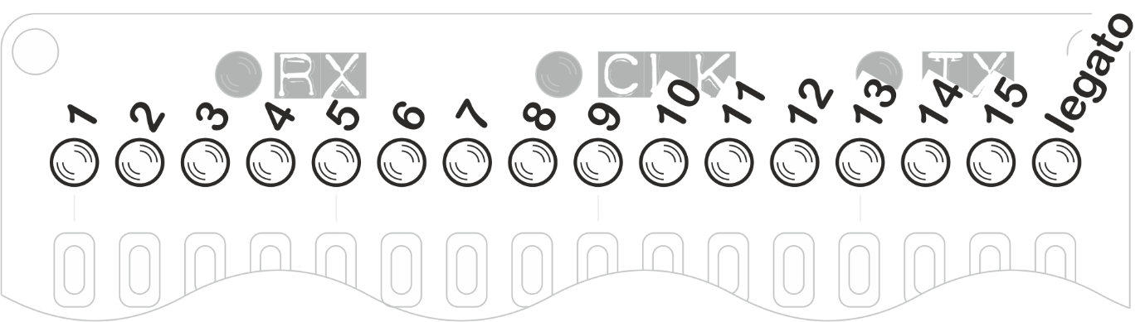

Controls the gate length of the MIDI notes played by ARPIE. You can select a proportion of a whole step (in fifteen increments) or you can tie notes together with the legato setting.

**legato** means that a note is held until the next note is started, with the MIDI note off message being sent after the next MIDI note on. This allows notes to play right across rests in the rhythmic pattern allowing for some nice grooves.

|  |  |
| --- | --- |
| INST | Arp Note Insert / Chord |

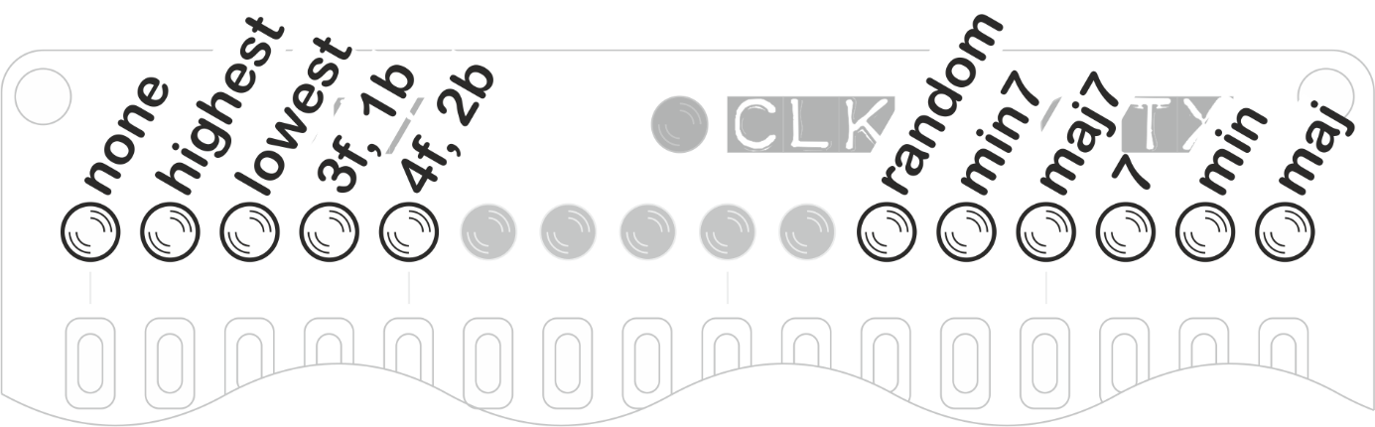

This extends the length of the arpeggiated sequence by repeating notes from the chord as follows:

* **none** plays the arpeggio sequence without adding any extra notes to it. This is the default.
* **highest** inserts the highest note of the arpeggio sequence in between all the other notes
* **lowest** inserts the lowest note of the arpeggio sequence in between all the other notes
* **3f, 1b** staggers the arpeggio sequence and introduces repetition of notes by playing forward three places then moving back one place and continuing.
* **4f, 2b** staggers the arpeggio sequence by moving forward four places then back two.

To the right of the screen are some options for inserting chords without a keyboard. **random** creates a chord from randomised notes. The other buttons insert minor, minor seventh, major seventh, seventh. minor, major chords. The root note is C but you can use the TRAN function to change this.

The HOLD function engages automatically have you insert a chord.

|  |  |
| --- | --- |
| *INST | Manual Chord |

A long press of the INST button takes you to the manual chord insertion screen. Here you can play a chord by simply pressing buttons to toggle notes on and off.

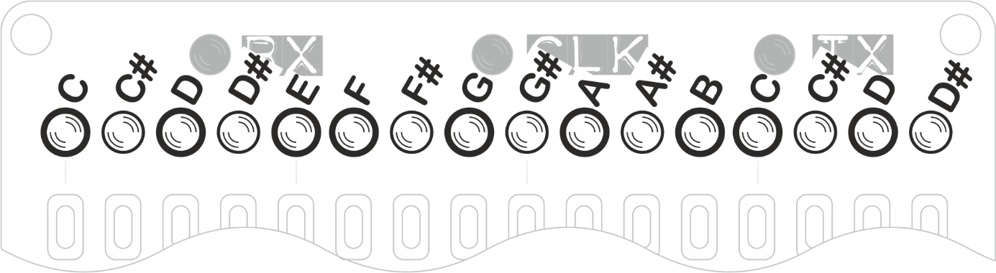

The HOLD function engages automatically have you insert a chord.

|  |  |
| --- | --- |
| SYNC | Clock Source & BPM |

This screen controls the ARPIE’s MIDI SYNC mode and its internal metronome.

The **source** button controls the clock source. When the LED in off, ARPIE runs from its own internal clock source. When the LED is on, ARPIE runs on external MIDI clock via the MIDI IN or MIDI AUX sockets.

The **send clock** button controls whether ARPIE sends a MIDI beat clock to the MIDI OUT port. The clock is sent when the option is ON. When this option is switched from OFF to ON, ARPIE also sends a ‘start’ command to the OUT port, which can be used to synchronize other MIDI devices. Conversely, a MIDI `stop’ command is sent when the Send function is switched off.

The function of the other buttons depends on the selected clock source. For internal clock, the mapping is as follows

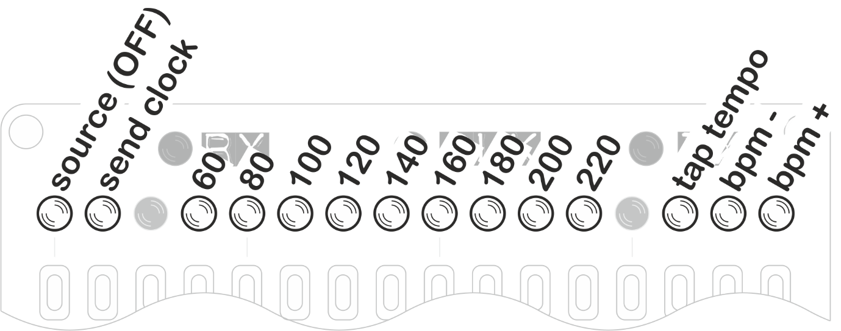

When ARPIE is running from its internal clock, the BPM buttons can be used to set the tempo to one of eight specific values from 60bpm to 220bpm (BPM defaults to 120 when ARPIE is switched on)

Pressing the **tap tempo** button two or more times allows you to set the tempo interactively. The **bpm+** and **bpm-** buttons can be used to adjust the BPM by steps of 1.

For an external clock source, the mapping is as follows

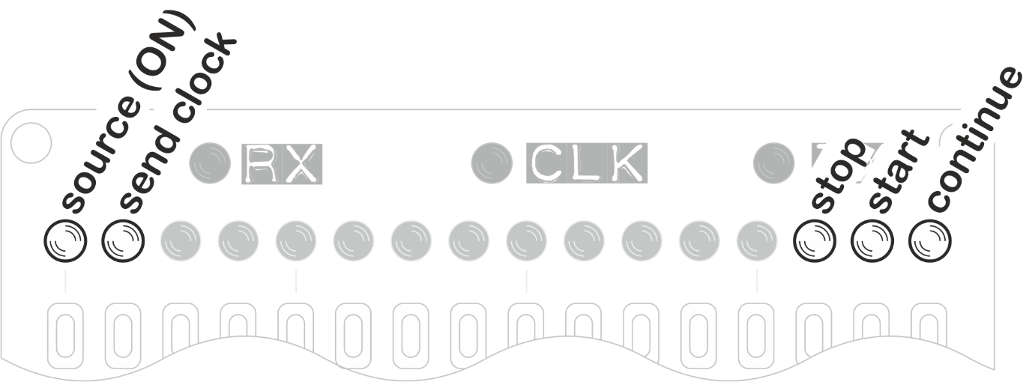

While ARPIE is running from an external clock the rightmost 3 buttons can be used to override the external transport. This is particularly useful if you want to start ARPIE playing without having to send a transport start command over MIDI from the clock master.

**Note:** The internally generated BPM is approximate (but good enough for most stuff). However, an external clock source is recommended if a precise BPM is needed.

|  |  |
| --- | --- |
| *SYNC | MIDI Options |

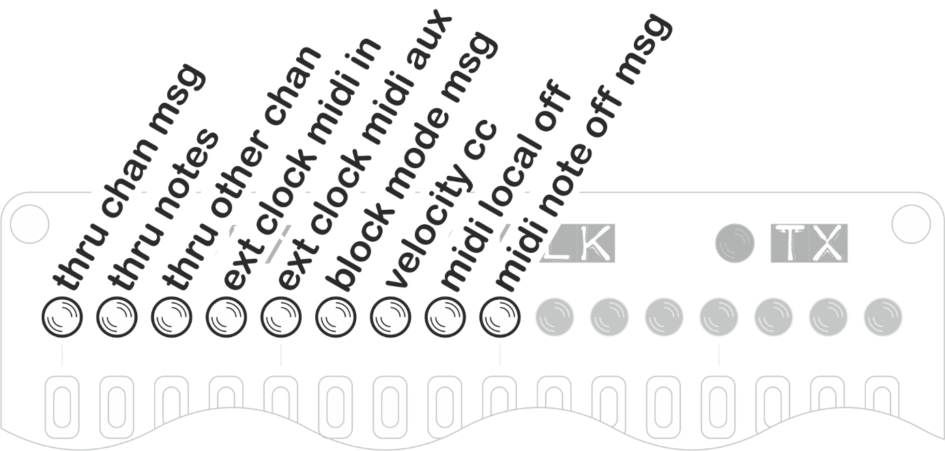

These options give you control over how ARPIE internally routes MIDI information.

* **thru channel msg** can be switched on so that non-note channel messages (CC change, pitch bend etc) which are received on ARPIE’s configured input channel, can be sent through to ARPIE’s output channel. This allows the performance parameters to be sent from your controller keyboard to your synth.
* **thru notes** - If you have ARPIE listening on a specific input channel (not Omni mode) then this option controls whether note messages for other channels will be passed directly through to ARPIEs MIDI output.
* **thru other chan** controls whether non-note channel messages (CC, bend etc) for other channels will be passed through to ARPIEs MIDI output.
* **ext clock midi in** determines whether ARPIE will listen for external MIDI clock ticks on the MIDI IN port. Source must also be set to external for these to be used.
* **ext clock midi aux** determines whether ARPIE will listen for external MIDI clock ticks on the AUX MIDI SYNC port. Source must also be set to external for these to be used.
* **block mode msg** - When ON, ARPIE will remove MIDI ‘Channel Mode Messages’ (CC numbers 120 thru 127) from the data sent through from input to output. E.g. Some controllers might send unwanted channel mode messages such as ‘all notes off’ when releasing keys - ARPIE can filter these out.
* **velocity cc** - ARPIE sends CC41 before each note to set the velocity. This is specifically aimed at users of Korg Volca FM which does not respond to MIDI velocity.
* **midi local off msg** - When enabled, Arpie sends MIDI LOCAL OFF message on each MIDI channel at start-up time. Toggling the setting also sends LOCAL OFF or LOCAL ON messages (depending on the new value of the setting) at the time the button is pressed.
* **midi note off msg** – Arpie usually uses a zero velocity note on message to silence notes – this allows more efficient use of the MIDI bandwidth via ‘running status’. However, some older synths might need a “real” note off message to stop notes playing. Enabling this option means these note off messages will be used, which can help prevent stuck note issues.

**Note:** MIDI thru is handed in ARPIEs firmware (there is no hardware thru) which can cause latency if the engine is busy and possibly even dropped messages in situations of very high thru volume – but this is rare.

|  |  |
| --- | --- |
| CHAN | MIDI Output Channel |

When pressed, selects and displays the channel for MIDI output. Notes played by Arpie are output on this channel.

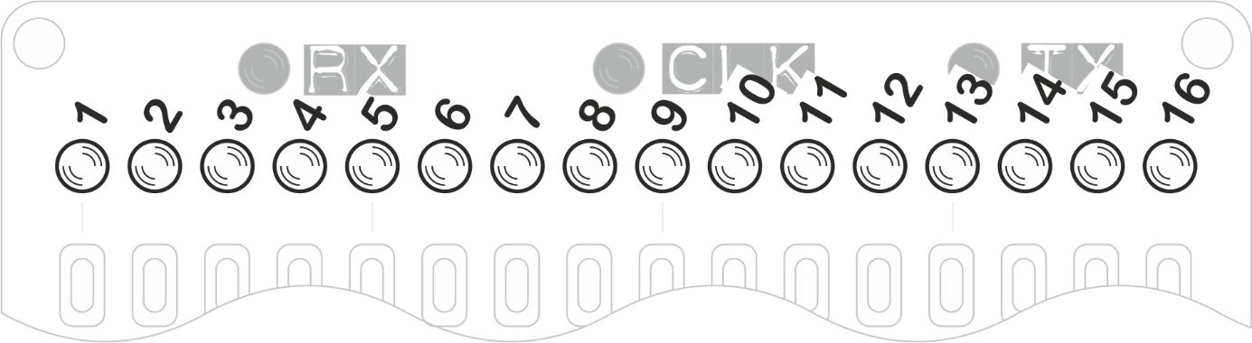

|  |  |
| --- | --- |
| *CHAN | MIDI Input Channel |

If the CHAN button is pressed and held for a couple of seconds, you can Select The MIDI input channel. By default ARPIE will accept input from any MIDI channel (OMNI mode) but you can also select a specific channel, which affects MIDI Thru behaviour (see below).

OMNI mode is indicated by all the LEDs being ON. Pressing any single button will select an individual input channel. Pressing the same button again will restore OMNI mode.

|  |  |
| --- | --- |
| TRAN | Chromatic Transpose |

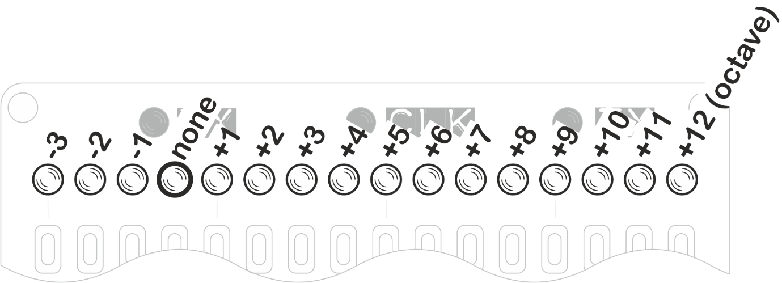

Pressing a button on this screen transposes the running arpeggio up or down by a selected intervals between 1 octave up and 3 semitones down

It’s also possible to sequence the transposition, allowing one of ARPIEs most exciting features! Create a transpose sequence by holding the TRAN button down while pressing a sequence of the interval buttons. The sequence will play back with each transposition step effective for the PLEN setting length. Stop the sequence by simply creating a new sequence with a single step.

Transpose (sequenced or otherwise) works best when used in conjunction with the force to scale modes. This ensures that all transposed notes in the arpeggio are kept in key.

|  |  |
| --- | --- |
| HOLD | Chord Hold |

The HOLD button stops ARPIE forgetting your chord once you stop playing it on an attached MIDI keyboard. If you do not have HOLD engaged, ARPIE plays immediately from the start of the trig sequence when you press a chord and stops again when you release the chord. If you use the HOLD button, the current chord plays until you press a new one, playback between chords stays in time

|  |  |
| --- | --- |
| *HOLD | MIDI Lock / MIDI Transpose |

When the HOLD button is held for a few seconds, the HOLD LED starts to blink, indicating that the secondary function is active. There are two functions available, you can select between them from the performance options menu (long press MODE). These are described below.

* **MIDI Lock** - This function can be used to `lock’ the arpeggiator engine and start passing MIDI notes from input to output. This allows you to hold an arpeggio and then play over it. MIDI lock can also be useful if you chain together multiple ARPIEs and want to play into a single one at a time while the others are playing sequences in hold mode. Exit MIDI lock by pressing HOLD again. ARPIE will return to the previous HOLD mode.
* **MIDI Transpose** - This function works a bit like MIDI lock, except that instead of passing input notes through to the output, a held arpeggio is transposed according to the interval between the note you play on the input and the lowest note in the arpeggiated chord. This function is designed to work with the HOLD feature. You can have great fun when using this with force-to-scale options!

## Firmware Version Display

To check the firmware version of your Arpie, press down HOLD while powering up or resetting. While HOLD is pressed, the data LEDs will show the current version using the following method

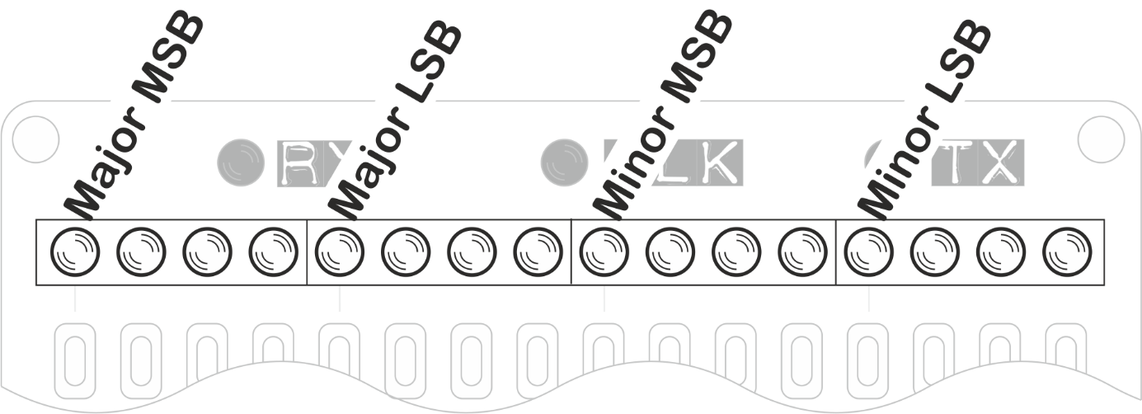

Each group of 4 LEDs shows a single decimal digit, encoded in binary, with a lit LED being a 1 and an unlit LED being a 0. The digits from 0-9 are represented as follows

|  |  |  |  |  |
| --- | --- | --- | --- | --- |
| **LED1** | **LED2** | **LED3** | **LED3** | **Digit** |
|  |  |  |  | 0 |
|  |  |  | ON | 1 |
|  |  | ON |  | 2 |
|  |  | ON | ON | 3 |
|  | ON |  |  | 4 |
|  | ON |  | ON | 5 |
|  | ON | ON |  | 6 |
|  | ON | ON | ON | 7 |
| ON |  |  |  | 8 |
| ON |  |  | ON | 9 |

For example the following is how version 5.12 would be displayed

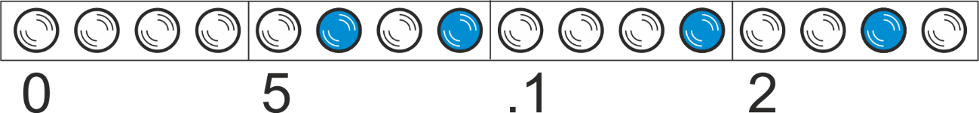

## Factory Reset

A reset of all Arpie settings can be triggered by pressing and releasing the MODE button while the version number is displayed. i.e. Press HOLD during power up, then while still pressing HOLD, press and release MODE. All the data LEDs should light up briefly.

## Hack Header

Arpie has an expansion port called the “hack header”, which is a 6-pin connector on the lower board, next to the dual row connector that connects the top and bottom boards.

The firmware supports running this header in several different modes that are designed to support specific pieces of external hardware that are connected to it. Each of these extra modules (called “tabs”) is described in detail in the following sections.

With the exception of the Control Tab (which sits outside the Arpie case) each tab fits between the top and bottom boards of the Arpie. The six connector pins fit into the hack header and the tab is held firmly in place by passing through it the two rows of connection pins from the top board. Here is how the CV tab fits in the case.

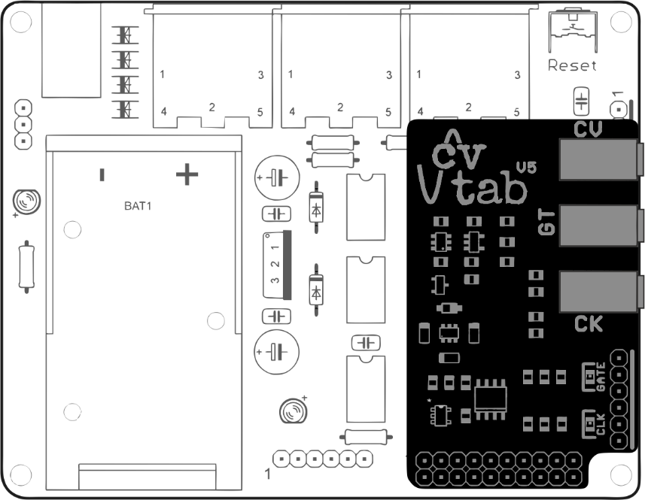

**Note:** When fitting the tab, make sure that the underneath of the tab board is not touching the programming header pins (if a pin header is soldered there). A pin header could be trimmed slightly or bent slightly outwards if touching the tab board.

**Note:** Only one tab can be connected and used at a time!

In order to activate the hack header, you first need to select the mode based on what hardware is connected. You do this by pressing one of the following buttons while the firmware version number is displayed (i.e. hold down HOLD while powering up or resetting)

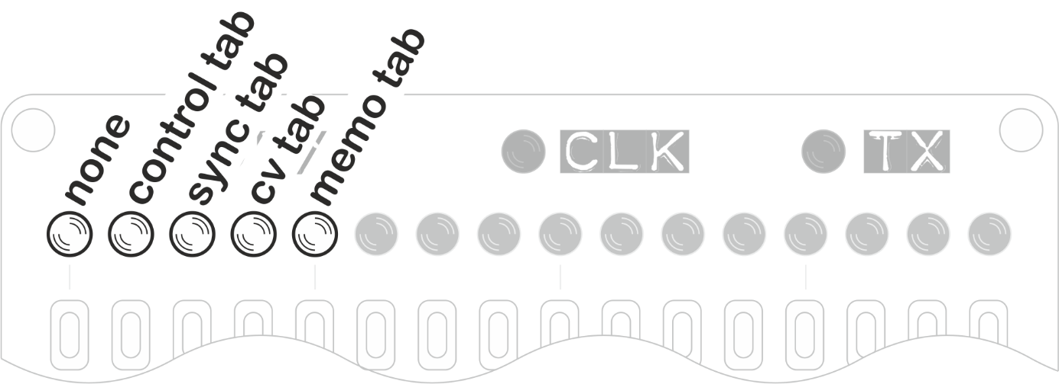

After pressing the appropriate button, release the HOLD button to let the Arpie start up. You should see your selection highlighted briefly before normal operation begins. This selection remains active until you change it or do a settings reset, so remember to change the setting if you change or remove a connected “tab”

**Note**: If you have an incorrect mode selected, this can prevent the Arpie working properly until you select the correct mode or **none**. A full settings reset will also revert to **none**

The following signals from the ATMEGA microcontroller are present at the Hack Header

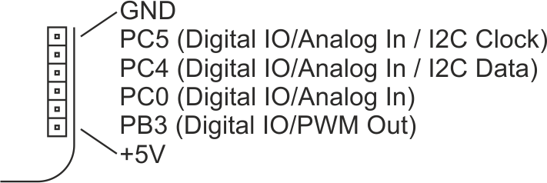

These pins can support some interesting functions that open up other possibilities for experimentation (as long as you are able to get your hands dirty in the code!).

● PC5 this is Arduino analog input 5. It is also the clock line for I2C and is a general purpose digital input or output (Arduino digital pin 19) which can support interrupt on pin change (PCINT13)

● PC4 this is Arduino analog input 4. It is also the data line for I2C and is a general purpose digital input or output (Arduino digital pin 18) which can support interrupt on pin change (PCINT12)

● PC0 this is Arduino analog input 0. It is also a general purpose digital input or output (Arduino digital pin 14) which can support interrupt on pin change (PCINT8)

● PB3 this is Arduino digital pin 11, supporting a PWM (Arduino analogWrite) output and interrupt on pin change (PCINT3)

● VCC and GND regulated +5V supply from internal LDO regulator. Do not draw more than a few tens of milliamps from this supply!

Since the header breaks out the I2C bus, peripherals such as DACs, EEPROMs, Accelerometers etc could be supported with additional firmware code. The presence of a PWM output allows generation of a control voltage that could be used to drive external equipment (although only 8 bit resolution is supported by Arduino analogOut)

## Control Tab

The Control Tab is a module containing 3 potentiometers and a switch, that can be assigned various specific control functions

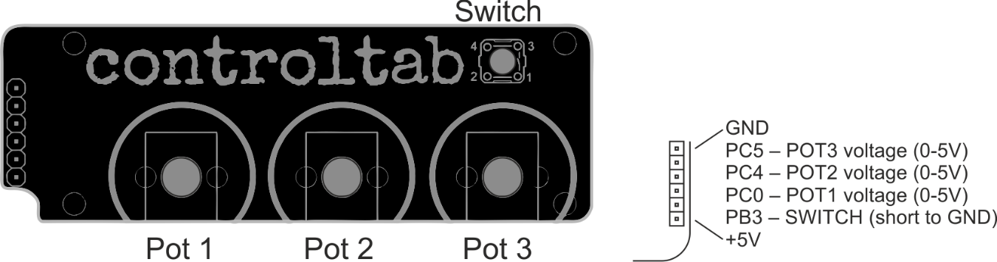

**Tip:** You can attach your own potentiometers (100k Ohm or similar) and a switch to the Hack Header without using the Control Tab. Each potentiometer should be wired as a “voltage divider” with low end of track connected to GND and high end of track connected to +5V, with the wiper connected to the corresponding POT input on the hack header as shown in the diagram above right. The switch should short the switch input to GND when pressed.

The actual functions for each potentiometer and switch are selected via the long-press PLEN menu, on LEDs 2-8 as follows

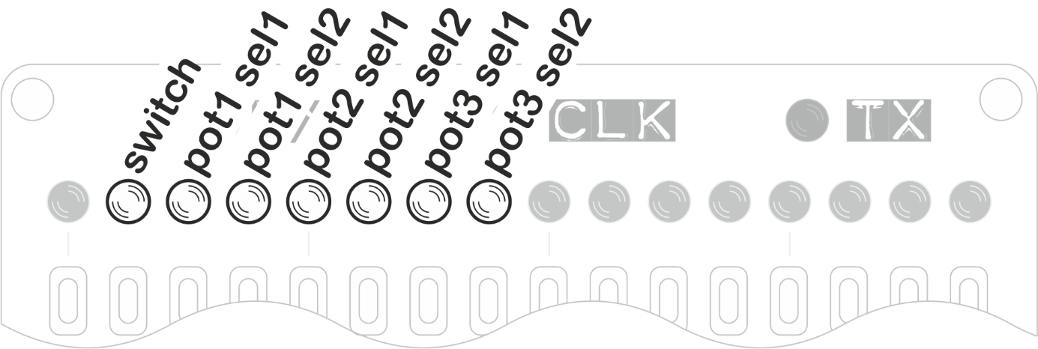

LED 2 controls the Arpie function mapped to the switch input

|  |  |
| --- | --- |
| **Switch** | **Switch Press Mapped to Function** |
| OFF | Mute MIDI out |
| ON | Restart bar |

LEDs 3/4 control the Arpie function mapped to the POT1 input

|  |  |  |
| --- | --- | --- |
| **pot1_sel1** | **pot1_sel2** | **Mapped to Function** |
| OFF | OFF | None |
| OFF | ON | BPM |
| ON | OFF | Gate Length |
| ON | ON | MIDI CC#16 |

LEDs 5/6 control the Arpie function mapped to the POT2 input

|  |  |  |
| --- | --- | --- |
| **pot2_sel1** | **pot2_sel2** | **Mapped to Function** |
| OFF | OFF | None |
| OFF | ON | Velocity |
| ON | OFF | MIDI Pitch Bend |
| ON | ON | MIDI CC#17 |

LEDs 7/8 control the Arpie function mapped to the POT2 input

|  |  |  |
| --- | --- | --- |
| **pot3_sel1** | **pot3_sel2** | **Mapped to Function** |
| OFF | OFF | None |
| OFF | ON | MIDI CC#1 (Mod Wheel) |
| ON | OFF | Transpose |
| ON | ON | MIDI CC#18 |

**Note:** If the control tab is not attached, make sure that the Hack Header mode is changed to None (or another mode), or the potentiometer functions are set to None. Otherwise the functions mapped to potentiometers can behave erratically and randomly.

## Sync Tab

The Sync Tab allows the Arpie to work with 5V pulse clocks (e.g. as used on Eurorack modular gear or small sequencers like Volca, Pocket Operator etc)

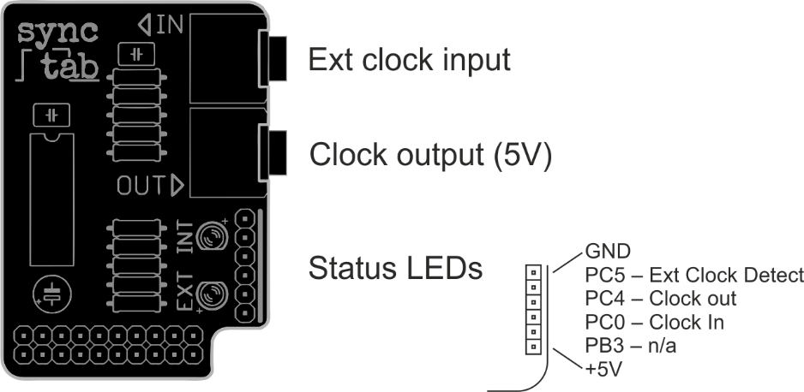

When a cable is connected to Ext Clock Input, the Arpie will function as a clock slave. You must reset Arpie after inserting or removing the cable from the Ext Clock socket.

When running from a regular external pulse clock, set Arpie to i**nternal** clock mode.

**Tip:** If Arpie is set to **external** clock mode and there is no incoming MIDI clock, the external pulse clock input will function as a single step advance, with one pulse advancing one step, regardless of RATE setting etc. The pulses do not have to be regular.

A signal received from Ext Clock input is duplicated at the Clock Output.

If there is no cable connected to Ext Clock Input, the Arpie will run using its internal clock, and will output 5V clock pulses from the Clock Output socket.

Pulses can be 1/8th or 1/16th of a note, depending on the setting of the **clock div** (LED 1 on the long-press PLEN menu)

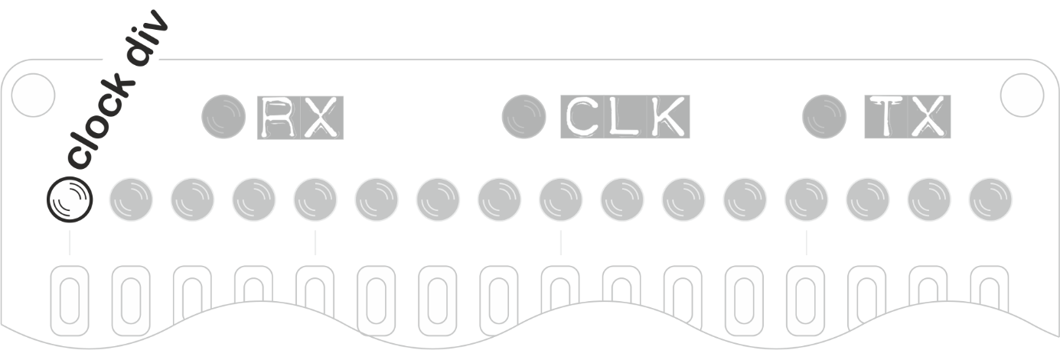

|  |  |
| --- | --- |
| **Clock div** | **Clock Rate** |
| OFF | 16th Note Clock Rate |
| ON | 8th Note Clock Rate |

## CV Tab

The CV Tab allows the Arpie to control analogue synth gear using standard CV/Gate connections. CV Tab also supports a pulse clock output which can optionally be set to output accent pulses instead.

In addition, **CV Tab includes the Memo Tab functionality**, allowing 16 patches (i.e. saved Arpie states) to be stored. This is described in the Memo Tab section.

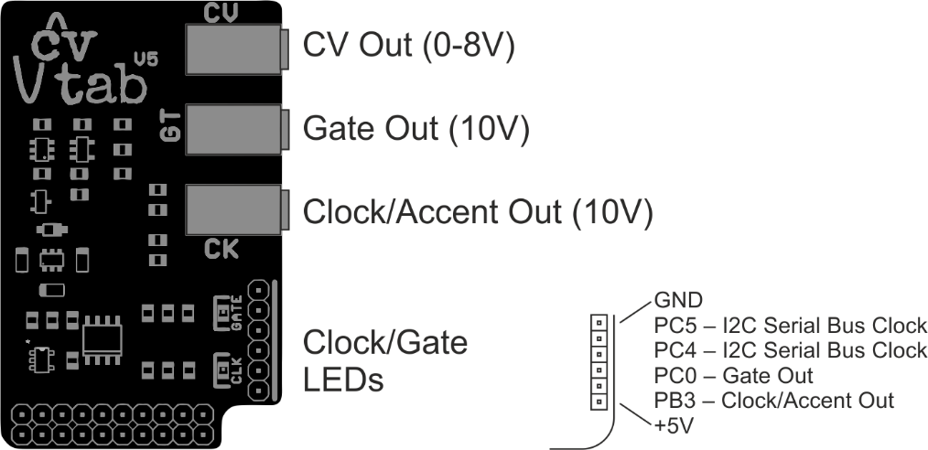

The CV Tab functions are selected via the long-press PLEN menu, on LEDs 2-8 as follows

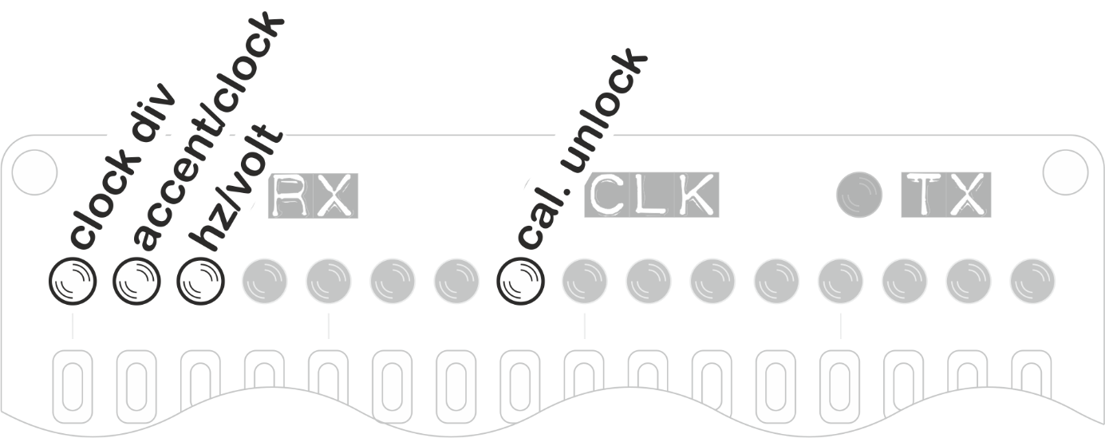

LED 1 controls clock division as follows:

|  |  |
| --- | --- |
| **Clock div** | **Clock Rate** |
| OFF | 16th Note Clock Rate |
| ON | 8th Note Clock Rate |

LED 2 selects between accent and clock output as follows:

|  |  |
| --- | --- |
| **Accent/clock** | **Clock Rate** |
| OFF | Clock out sends pulse clock |
| ON | Clock out sends accent |

Accent pulses are sent when accent is set for a step (PATN, accent layer).

LED 3 selects the pitch scaling to be used

|  |  |
| --- | --- |
| **Hz/volt** | **Clock Rate** |
| OFF | 1V/Octave scaling |
| ON | Hz/Volt scaling |

LED 8 unlocks the CV Tab pitch calibration settings. The CV TAB is factory calibrated, so you should not usually need to change this information. Otherwise you can change the calibration by sending specific MIDI CCs.

The CV TAB maps an 8 octave range to a 12-bit DAC resolution. The firmware allows compensation for any analog offset or gain error in the analog output buffer. A 7 bit gain compensation allows +/-63 DAC units to be added to the full voltage range

|  |  |  |
| --- | --- | --- |
| **MIDI CC** | **Action** | **MIDI CC Value** |
| 70 | Set scale compensation | 0-127 map to -63..0..+63. 64 is no compensation |
| 71 | Set offset compensation | 0-127 map to -63..0..+63. 64 is no compensation |
| 72 | Set CV output to test value | MIDI note number (0-127) |
| 73 | Save calibration settings and turn off calibration mode |  |

The CV Tab calibration settings are stored on the CV TAB itself. Each CV TAB is factory calibrated before sale.

If you need to **recalibrate** your CV Tab, you can use the following utility <https://github.com/hotchk155/arpie-cv-tab/blob/master/cal-tool/cal-tool.html>

This is a standalone HTML file which you can download (use “Raw” option) and save to your computer, then open it in a browser that supports WebMIDI (Such as Google Chrome)

Select the MIDI interface to which the Arpie (with CV Tab installed) is connected, enable calibration mode via hack header settings and follow the instructions on screen.

You will need a voltmeter with .001V accuracy to properly calibrate the CV Tab. Alternatively you can use a well-tuned VCO with an electronic tuner or frequency counter.

## Memo Tab / Patch Saving

Memo Tab (and CV Tab) contain a memory chip that enables Arpie patches to be saved and recalled later.

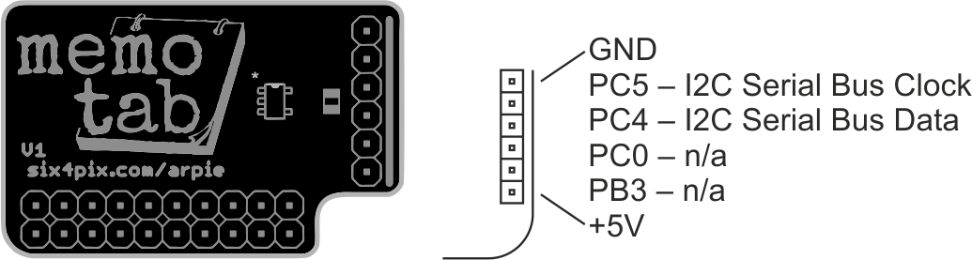

A total of 16 snapshot slots (i.e. “patches”) can be stored.

To **save** the current ARPIE state as a patch, press down HOLD, then quickly press PLEN. The screen changes to show the slot status (used slots are lit up brightly). Press one of the slot buttons to save the current ARPIE state to that slot. If there is already data in the slot it will be overwritten. You can save to multiple slots without having to press HOLD+PLEN again. Press a menu button (e.g. PATN) to exit from patch save mode.

To **load** the ARPIE state from a previous patch, press down HOLD, then quickly press PATN. The screen changes to show the slot status. Press one of the brighter lit (occupied) slot buttons to load the ARPIE state from that slot. The HOLD LED will automatically be engaged when the patch is loaded, so that the chord saved with the patch is not lost. You can press HOLD again to exit hold mode and clear the chord. To exit from the slot status display without loading a patch, just press another menu button (e.g. PATN)

To **clear** one or more slots, press down HOLD, then quickly press MODE. The screen changes to show the slot status. Press one of the brighter lit (occupied) slot buttons to clear it. You can clear out multiple slots without having to press HOLD+MODE again. To exit from the slot status display just press another menu button (e.g. PATN)

**Note:** holding the HOLD button for a couple of seconds will activate the hold second function (LED starts blinking) after which the shift function is cancelled– this means that to access the Memo Tab functions, the second key must be pressed immediately after pressing HOLD.

## Firmware Update Procedure

New versions of the Arpie firmware may be released on an occasional basis to add new features, support new hardware add-ons and to fix bugs. These new releases are made available as pre-programmed microcontroller chips which can simply be swapped with the older chip.

However, with a suitable programmer, you can update the firmware on an existing Arpie without a need to replace the chip.

The type of programmer needed is a USB to TTL serial programmer, which are most commonly based on the FTDI FT232 chipset or the Silicon Labs CP2102 chipset. A programmer with 5V output levels is needed, and you must have installed the appropriate drivers for your OS.

The programmer usually sold with the Arpie kit is the Silicon Labs CP2102. You can download drivers here: <http://www.silabs.com/products/mcu/Pages/USBtoUARTBridgeVCPDrivers.aspx>

You will need to download and install the free Arduino environment from <http://arduino.cc> and the source code for the latest Arpie firmware release from [https://github.com/hotchk155/Arpie/tree/master/releases](https://github.com/hotchk155/arpie/tree/master/releases). When you download the firmware source code from Github, make sure you save the “Raw” file, not the HTML page where the code is viewed. Click on the “Raw button in GitHub and make sure the code is saved with a .INO extension.

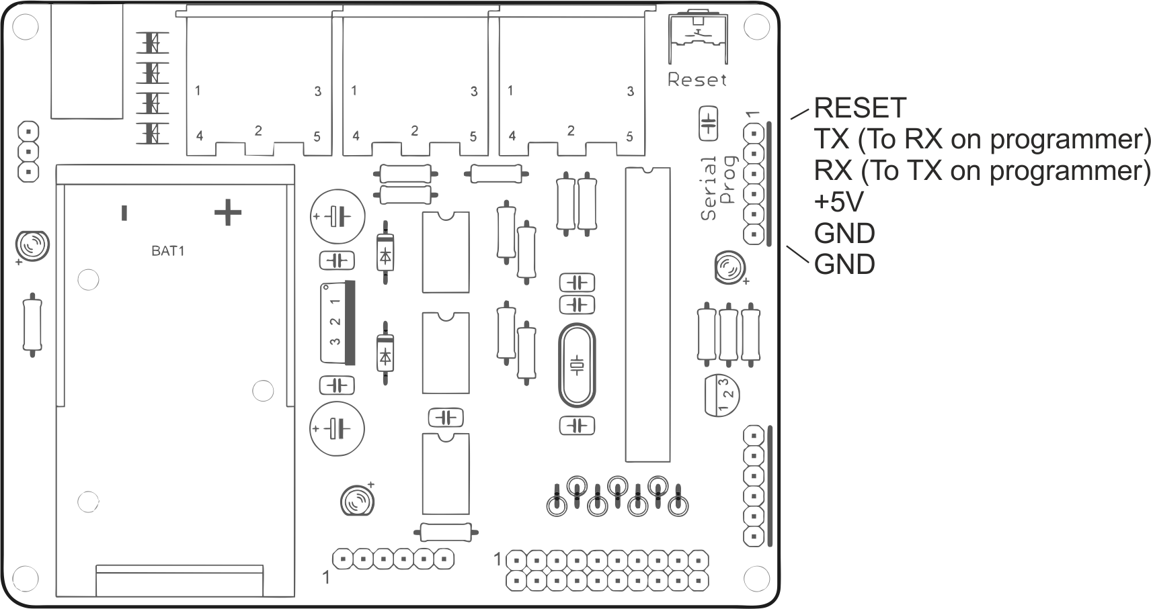

The programmer connects to the 6 pin programming header (ICSP1) on the ARPIE main board. This is the connector near to the reset button.

The ordering and labelling of pins on the programmer can vary depending on the exact type. If you have an FTDI programming cable with a 6 pin female header, you should be able to connect it directly to the programming header.

With other types of programmer you’ll need to connect the individual pins of the programmer to corresponding pins on the header, using the provided jumper cables as follows

|  |  |  |
| --- | --- | --- |
|  | **Arpie Pin** | **Connected Programmer Pin** |
| 1 | Reset | Reset / RST or leave unconnected |
| 2 | TX (Transmit) | RX (crossed over) |
| 3 | RX (Receive) | TX (crossed over) |
| 4 | +5V | +5V / VCC / VDD |
| 5 | GND | GND |
| 6 | GND | Leave unconnected |

The pin 1 end of the connector on the Arpie board is indicated with a digit “1”. It might be necessary to take out the screws and remove the top ARPIE PCB to access the programming header. The control surface does not need to be attached during programming.

Disconnect all MIDI connections during programming and make sure that the Arpie **is powered** via battery or DC socket and is switched on (it might look powered up as soon as USB is connected but you MUST power Arpie normally and make sure it is switched on during programming)

Open the firmware file in Arduino (you will get prompted that the code has been placed automatically in an “Arpie” folder)

In the Arduino environment, select the COM port for the programmer (which is usually the highest numbered port and appears only when the programmer is attached) and select Board Type “Arduino Duemilanova” and processor type “ATMega 328”

Press Ctrl-U to compile the code and upload to the ARPIE. Compilation takes a few seconds - get ready to press the reset button on the ARPIE… as soon as the message on the Arduino status bar changes from “Compiling” to “Uploading”, press the reset button on the ARPIE board. Within 10-15 seconds you should have a “Done” message in the Arduino environment status bar and the ARPIE has been updated.

You can check the firmware version installed on an ARPIE by holding the HOLD button while the device boots up as described previously.

Disconnect the programmer from the header before reattaching the MIDI cables.

For troubleshooting information please check [https://six4pix.net/product/Arpie/#tab-diagnostics-faq](https://six4pix.net/product/arpie/#tab-diagnostics-faq)